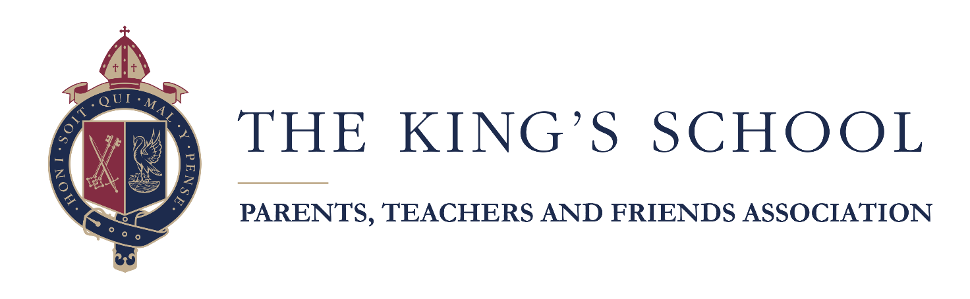

EXCLUSIVE GOLD PRIZE DRAW - APPLICATION FORM
To the Manager
Bank
Address
Post Code

Please debit my/our account:
ACCOUNT NAME
Account No:
Sort Code
with the sum of £10.00 (ten pounds) on the 01 November 2026 (ANNUALLY)
and ANNUALLY on the anniversary of the first payment until further notice and pay to Lloyds Bank Plc., Grantham, sorting code: 30-93-58 for the account of: -
The King’s School, Grantham, Parents’, Teachers’, and Friends’ Association Exclusive Gold Prize Draw (King’s PTFA Prize Draw), account number: 00678326,
Quoting reference: / / (to be supplied by the promoter)
Signature(s)
Name(s) in block capitals
Full Address
Post Code
Telephone number (Mobile)
E-Mail Address
Son’s Name
Form
DO NOT SEND THIS FORM TO YOUR BANK/BUILDING SOCIETY AS THE REFERENCE MUST BE ADDED FIRST
PLEASE RETURN THE COMPLETED FORM TO: The King’s School, PTFA Prize Draw, Brook Street, Grantham, Lincolnshire, NG31 6RP. Please allow 10 working days. Each entry must be on a separate standing order/entry form.

